**IT SOLUTIONS:**  
 IT Solution offers to its clients a very rich selection of IT services for application software development, web solutions & multimedia solutions. We offer services in various technological areas and domain areas. The following areas include:

**Project Management**:   
 Project management, is the application of knowledge, skills, tools, and techniques to project activities to meet the project requirements.

Project management processes fall into five groups:

1. Initiating:

In the initiating processes determine the nature and scope of the project.If this stage is not performed well, it is unlikely that the project will be successful in meeting the business’ needs.

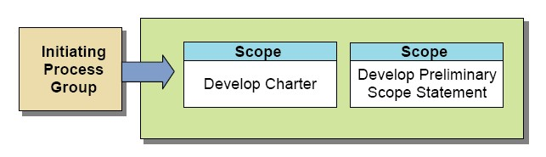

1. Planning:

After the initiation stage, the project is planned to an appropriate level of detail.The main purpose is to plan time, cost and resources adequately to estimate the work needed and to effectively manage risk during project execution. As with the Initiation process group, a failure to adequately plan greatly reduces the project's chances of successfully accomplishing its goals.

1. Executing:

While executing we must know what the planned terms that need to be executed are. The execution/implementation phase ensures that the project management plan's deliverables are executed accordingly. This phase involves proper allocation, co-ordination and management of human resources and any other resources such as material and budgets. The output of this phase is the project deliverables.

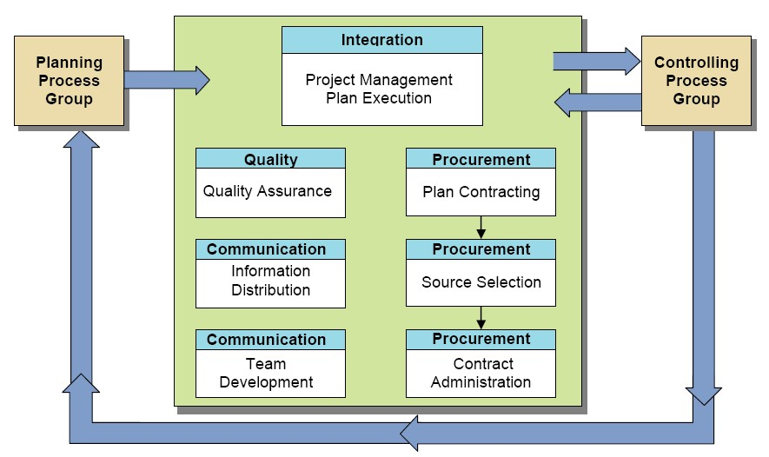

1. Monitoring and Controlling:

Monitoring and controlling consists of those processes performed to observe project execution so that potential problems can be identified in a timely manner and corrective action can be taken, when necessary, to control the execution of the project. The key benefit is that project performance is observed and measured regularly to identify variances from the project management plan.

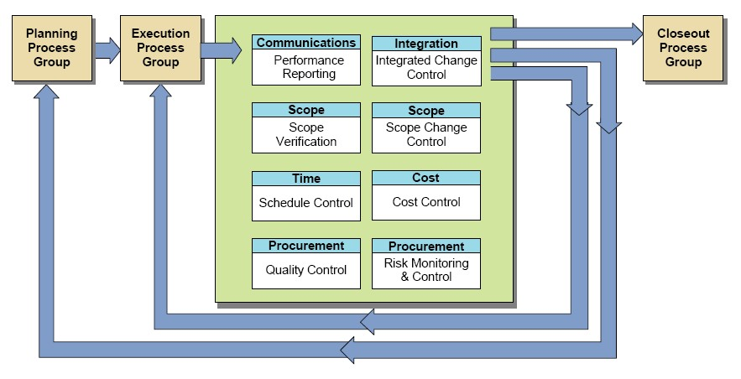

1. Closing:

Closing includes the formal acceptance of the project and the ending thereof. Administrative activities include the archiving of the files and documenting lessons learned.

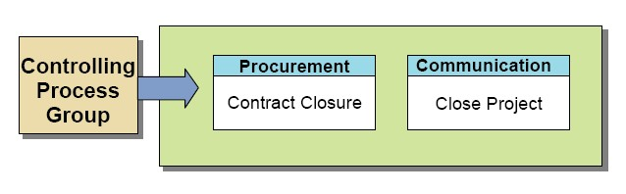

**Program Management**:   
 It is the [process](http://www.businessdictionary.com/definition/process.html) of managing multiple related projects at once. [Project management](http://www.businessdictionary.com/definition/project-management.html) is often used to describe one [project](http://www.businessdictionary.com/definition/project.html) where program management involves multiple projects that are all related and work towards the same [goal](http://www.businessdictionary.com/definition/goal.html) or [result](http://www.businessdictionary.com/definition/result.html). Program management is done by working closely with key stakeholders, leading the client through the planning andproject definition effort, eventually structuring the program within various key projects,allocating leadership roles out amongst us (optima) and the client organization.Optima can also assisted in the development and management of the operational structure, including the reporting approach, sponsor teams, timelines and critical milestones. Moreover, managing critical program functions, like process mapping, testing and software development are also provided.

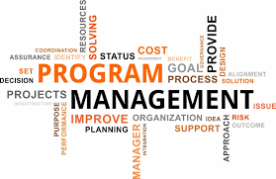

**Business Intelligence**:   
 Business intelligence (BI) is a technology-driven process for analyzing data and presenting actionable information to help executives, managers and other corporate [end users](http://whatis.techtarget.com/definition/end-user) make informed business decisions.

We first analyze the way how companies make decisions and consider the information that executives need to facilitate more confident and more rapid decision-making, as well as how they’d like that information presented to them (for example, as a report, a chart, online, hard copy). Discussions of decision making will drive what information companies need to collect, analyze and publish in their BI systems. Optima provide the service of this BI system.

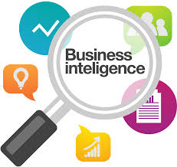

**Data Analytics**:  
 Data analytics refers to qualitative and quantitative techniques and processes used to enhance productivity and business gain. Designing strategies and programs to collect, store, analyze and visualize data from various sources for specific projects. Our consulting firm is able to lead a team and project, while ensuring the quality and on-time delivery according to the specifications. We develop data solution recommendations and ensure implementation of the chosen data solution. Through Optima data analytic service client can translate technology into business value by driving out costs or increasing revenues.

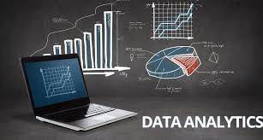

**Database Management**:   
 A database management system (DBMS) is system software for creating and managing [databases](http://searchsqlserver.techtarget.com/definition/database). The DBMS provides users and programmers with a systematic way to create, retrieve, update and manage [data](http://searchdatamanagement.techtarget.com/definition/data).

Our database experts will solve your complex business problems with the help of Database Management systems like Oracle and SQL server. Database monitoring, maintenance and troubleshooting are critical to DBA consulting support services. DBMS system can help companies with different business needs evaluate their current database & and develop a comprehensive DBMS plan that ensures 24*7 services with minimum service outages.

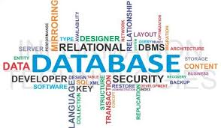

**Application Development**:   
 Software development is the process of conceiving, specifying, designing, programming, documenting, testing, and bug fixing involved in creating and maintaining applications, frameworks, or other software components. Optima’s experienced team of application developers assist organizations through a range of activities spanning the full software development life cycle (SDLC), including  
  
1)Application Design and Development:  
Providing a full range of development activities, including coding, testing, debugging, documenting, maintaining, and modifying applications  
Designing a great User Interface (UI) and User Experience (UX) for applications  
Creating builds for software releases for quality assurance and client user acceptance testing

2)Application Integration  
Enabling integration between applications and systems  
Working with APIs, Web services, and connectors

3) Application Modernization  
Modernizing legacy systems to align with current business needs, capitalize on new capabilities,  
improve agility, reduce risk, and reduce cost

4)Application Management and Support  
Providing application management and support services for new and existing applications

Resolving technical and functional issues as needed

5)Application Maintenance  
Conducting reviews to ensure standards and requirements are being met  
Ensuring systems are performing optimally



**Agile Transformation**:   
 The agile transformation defines an act of transforming an organization’s form or nature gradually to one that is able to embrace and thrive in a flexible, collaborative, self-organizing, fast changing environment. The Agile Manifesto values and principles can be taught and exercised throughout any type of organization as it does not just apply to development teams.

The entireorganization needs to understand the definition of an agile transformation and the value of it in order to benefit from the rewards of achieving true, healthy agility. The complete cultural and organizational mind set must change to one that embraces a culture of self-organization and collaboration. Optima will help you to achieve higher goals by providing all these services.



